10. Draw a use case diagram for Library Management System is an automation system used
to manage a library and the different resource management required in it like
cataloguing of books, allowing check out and return of books, invoicing, user
management, etc. The user can search for books details using few book properties
(Book ID, Title, Author, and Publisher). Searching should return details about all the
book copies that match the search query.

AIM:

To design a UML diagram for a library management system.

PROCEDURE:

Identify Actors:
- User: Searches for and borrows books.
- Library System: Manages book inventory, checkouts, and returns.
Define Use Cases:
- Search for books using properties like Book ID, Title, Author, or Publisher.
- View details of available book copies.
- Borrow and return books.
- Manage user accounts, including registration and borrowing history.
Create Diagrams:
- Use Case Diagram: Represents user interactions with the library system.
DIAGRAM:

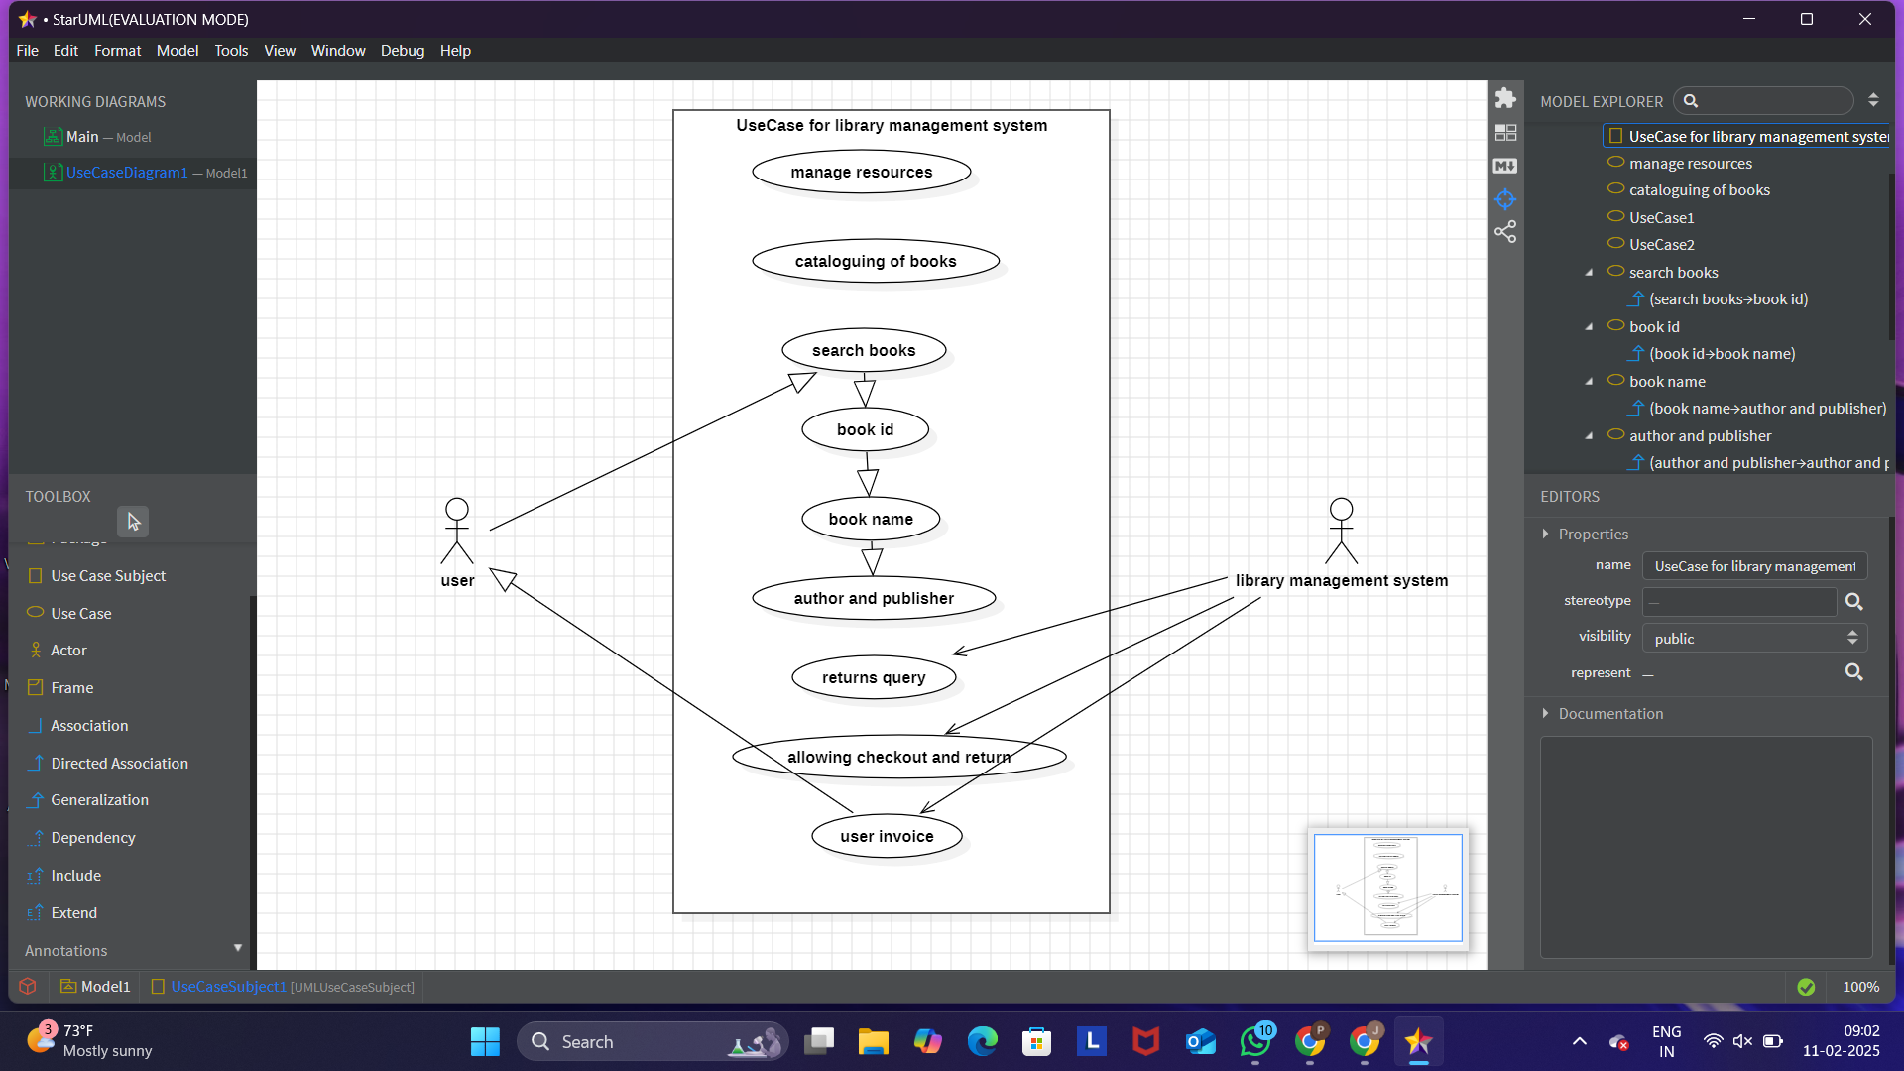

RESULT:

The UML diagram provides a structured representation of the library system, helping to streamline book cataloging, borrowing, and user management.

